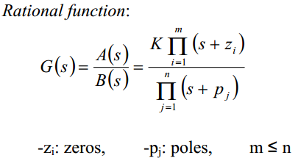

**LAPLACE TRANSFORMS**

Final Value Theorem

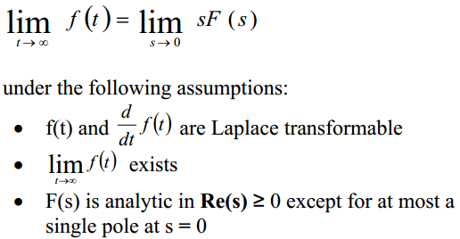

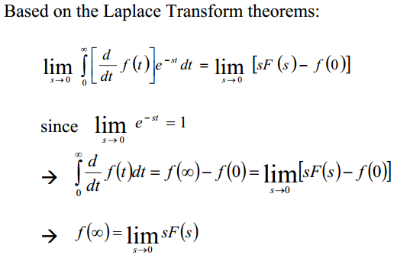

Initial Value Theorem

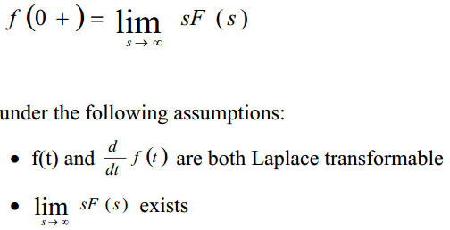

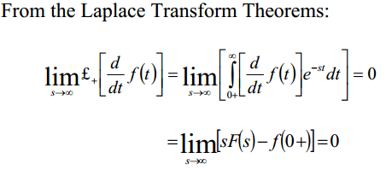

**SOLUTION OF LINEAR DIFFERENTIAL EQUATION**

**CLOSED LOOP**

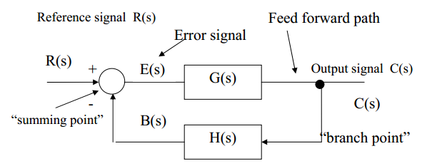

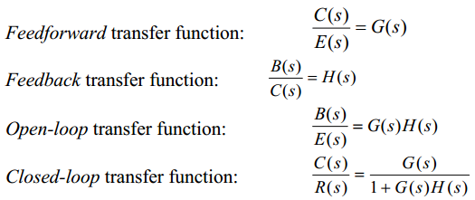

**STATESPACE REPRESENTATIONS**

To generate from a differential equation:

Use the **closed loop transfer function**

Separate and take the inverse Laplace transform

Then define state variables:

Then construct the state space matrix

and

values can be calculated as follows:

Where the values for come from:

To perform inverse (find transfer function from statespace model)

Where

And

The inverse of a square 2x2 matrix is found by:

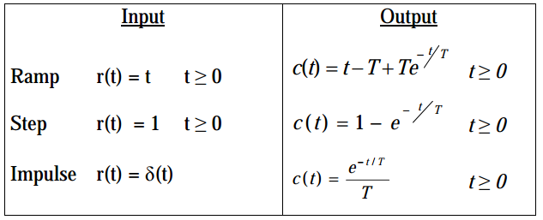

**SECOND ORDER SYSTEMS**

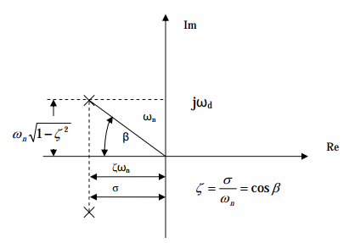

Imaginary axis:

Frequency of oscillations

Real axis:

Decay time

**UNIT STEP RESPONSE OF A 2ND ORDER UNDAMPED SYSTEM**

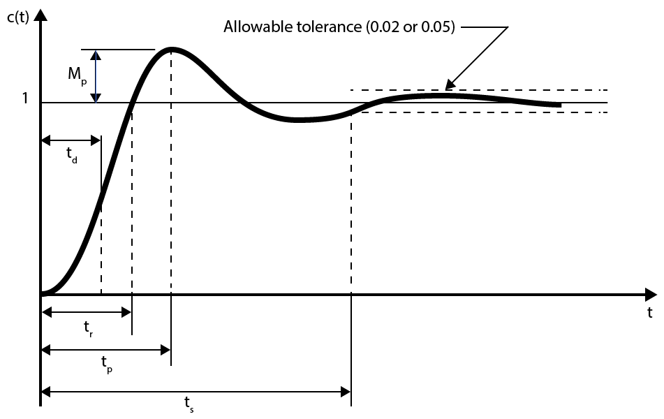

Dominant poles are the ones closest to the imaginary axis

**ROUTH-HURWITZ STABILITY TEST**

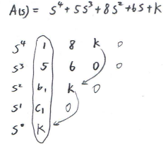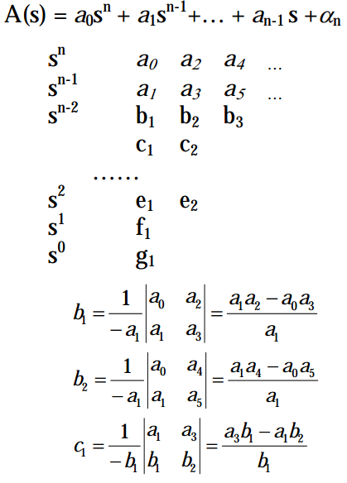

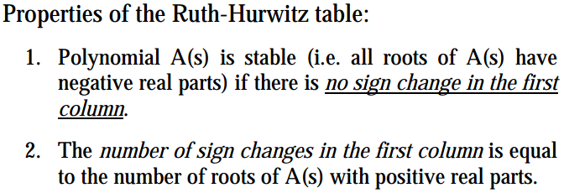

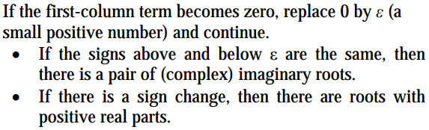

**STEADY STATE ERROR ANALYSIS**

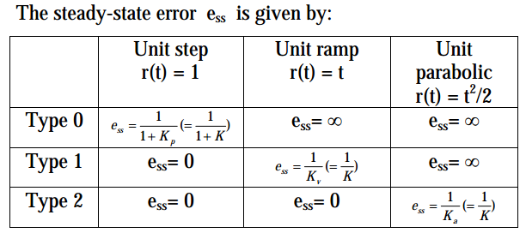

The type of system is determined by the number of poles at the origin. For example:

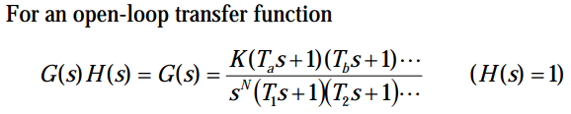

**ROOT LOCUS**

Root Locus presents the poles of the closed loop system when the gain K changes from zero to infinity.

**Construction of the Root Locus**

Open loop transfer function

m: the order of the **open-loop** numerator polynomial

n: the order of the **open-loop** denominator polynomial

**Rule 1:** number of branches equals the number of poles of the open-loop transfer function

**Rule 2:** If the total number of poles and zeros of the open-loop system to the right of the s-point on the real axis is odd, then this point lies on the locus.

**Rule 3:** The locus starting point (K=0) are at the open-loop poles and the locus ending points (K=∞) are at the open loop zeros and n-m branches terminate at infinity.

**Rule 4:** Slope of asymptotes of root locus as ‘s’ approaches infinity

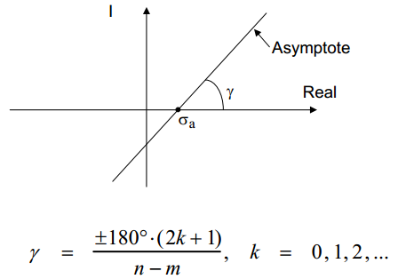

**Rule 5:** Abscissa of the intersection between asymptotes of root locus and real-axis.

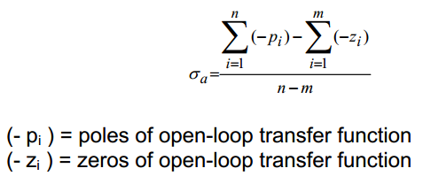

**Rule 6:** Break-away and break-in points. From the characteristic equation

The break-away and break-in points can be found from

**Rule 7:** Angle of departure from complex poles or zeros. Subtract from 180° the sum of all angles from all other zeros and poles of the open-loop system to the complex pole (or zero) with appropriate signs.

**Rule 8:** Imaginary-axis crossing points. Use Ruth-Hurwitz table to find value of K where system becomes unstable.

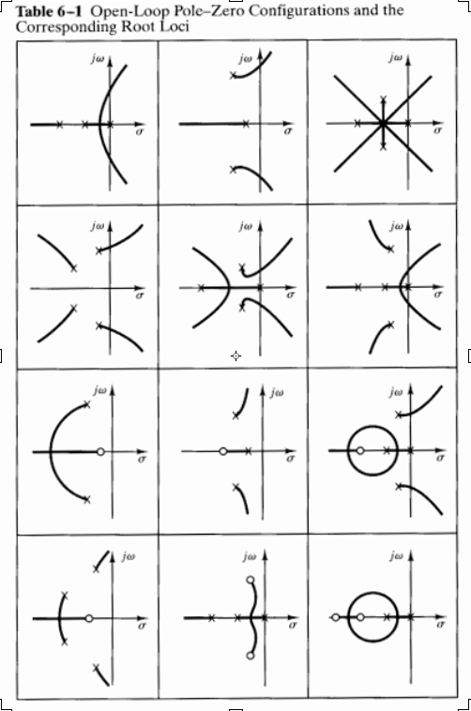

**BODE DIAGRAMS**

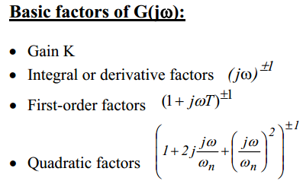

**1. Gain Factor K:** Horizontal straight line at magnitude:

Phase is zero.

**2. Integral or derivative factors**

Magnitude: strait line with slope -20 dB/decade

Phase: -90°

Magnitude: straight line with slope 20dB/decade

Phase: +90°

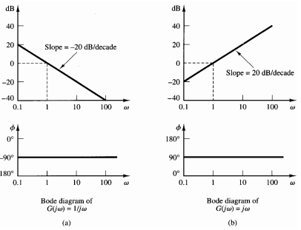

**3. First Order Factors**

Approximation for Magnitude:

Phase:

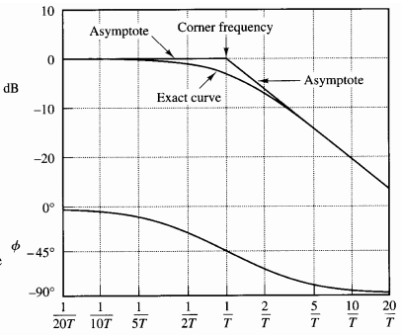

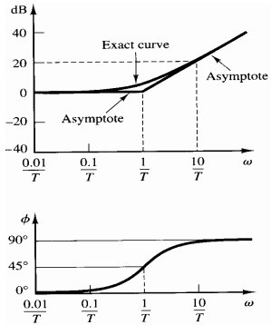

**4. Quadratic Factors**

Approximation for magnitude:

**FREQUENCY RESPONSE FOR NON-MINIMUM PHASE SYSTEMS**

Consider

Then…

And…

So if

**POLAR PLOTS (NYQUIST PLOTS)**

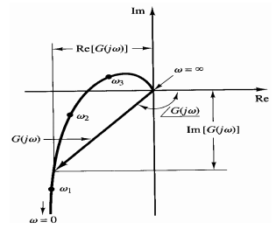

Generate based on the Bode Plot.

**The Nyquist Stability Criterion:** relates the stability of the closed loop system to the frequency response of the open loop system.

**Z:** Number of zeros of (1+H(S)G(s)) in the right half plane = number of unstable poles of the closed-loop system.

**N:** Number of clockwise encirclements of the point -1+j0.

**P:** Number of poles of G(s)H(s) in the right half plane.

If the plot makes a counter-clockwise encirclement of the -1+j0 point then N becomes -1.

If Z = 0 the closed loop system is stable. If Z > 0 the closed loop system has Z unstable poles. If Z < 0 a mistake has been made and the calculations need to be rechecked.

**PHASE AND GAIN MARGINS**

A measure for relative stability of the closed-loop system is how close , the frequency response of the open-loop system, comes to the point -1+j0. This is represented by the phase and gain margins.

**Phase Margin:** The amount of additional phase lag at the Gain Crossover Frequency required to bring the system to the verge of instability.

Gain crossover frequency:

Phase margin:

**Gain Margin:** The reciprocal of the magnitude at the Phase crossover frequency required to bring the system to the verge of instability.

Phase crossover frequency:

Gain margin:

Gain margin in dB:

**Minimum phase systems:** all poles and zeros are in the left half plane.

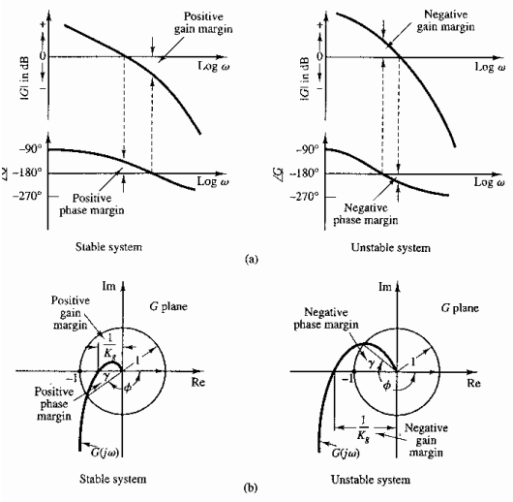

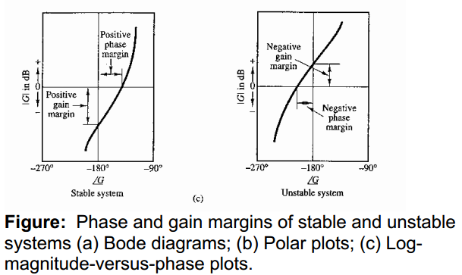

If the open-loop system is minimum phase and has both phase and gain margins positive then the closed-loop system is stable.

For good relative stability both margins are required to be positive.

Good values for minimum phase system are:

Phase Margin: 30°-60°

Gain Margin: above 6dB

